A

**Project Report**

on

**University Mailing System**

Submitted in the fulfillment of the requirement for Semester Project of Computer Networks

**Session (2023-2027)**



**Professor: Submitted By:**

**Kainat Nazir Muhammad Fahad 232448 Muhammad Bilal 232442**

***DEPARTMENT OF COMPUTING AND ARTIFICAL INTELLIGENCE AIR UNIVERSITY, ISLAMABAD, PAKISTAN***



# DECLRATION

I Muhmmad Fahad, and Muhmmad Bilal students of BSCS in the Department of Computer Science, Air University, Islamabad, under class Roll No. 232448, and 232442. for the session 2023-2027, hereby, declare that the project entitled “UNIVERSITY MAILING SYSTEM” has been completed by us during 4th Semester.

Date : Muhammad Fahad

(Roll No. 232448)

Muhammad Bilal (Roll No. 232442)

It is certified that the above statement to the best of my knowledge.

Date: Kainat Nazir

(Lecturer in CS)

Date: Shahzaib Abbasi

(co-ordinator)

# ACKNOWLEDGEMENT

This project is like pride between theoretical & practical knowledge. It is matter of great pleasure for me to submit this project on “UNIVERSITY MAILING SYSTEM”. This project will be great help in crucial times & will contribute in giving life to a person.

Firstly , I would like to thanks the supreme power, Allah Almighty who is really responsible for satisfactory completion of my task. Only because of his graceful hands that are always on me. I have been able to develop this project to help his creatures.

Secondly, I like to thank my parents who always help me financial and mentally. They always encourage me to be successfully in every field.

Muhmmad Fahad 232448.

Muhammad Bilal 232442.

|  |  |  |
| --- | --- | --- |
|  | **CONTENTS** |  |
| **Topic** |  | **Page No.** |
| Candidate’s Declaration |  | 2 |
| Acknowledgement |  | 3 |
| Introduction to Problem Area |  | 5 |
| |  | | --- | | Network Topology Design |  |  | | --- | |  | |  | 6 - 9 |
| |  |  | | --- | --- | | Server Room Setup |  | |  | 9 - 11 |
| |  |  | | --- | --- | | IP Addressing and Subnetting |  | |  | 11 - 13 |
| |  |  | | --- | --- | | DHCP Configuration |  | |  | 13 - 15 |
| |  |  | | --- | --- | | DNS and Mail Server Configuration |  | |  | 15 – 17 |
| |  |  | | --- | --- | | Static and Dynamic Routing |  | |  | 17 - 19 |
| |  |  | | --- | --- | | Testing and Validation |  | |  | 19 – 21 |
| |  | | --- | | Conclusion | |  | 22 |

# INTRODUCTION TO PROBLEM AREA

I

n today’s digitally driven academic environments, reliable and efficient network infrastructure forms the backbone of seamless educational operations. Faculties that specialize in computing and artificial intelligence, such as the Faculty of Computing and AI (FCAI), demand a well-structured and intelligently designed network to support their academic, administrative, and research activities. As the number of devices, users, and digital services increases within educational institutions, so does the complexity of managing and maintaining effective network communication.

The central challenge addressed in this project is the creation of a departmental network for FCAI that not only facilitates connectivity within individual departments but also ensures seamless communication across the entire faculty. The problem area includes the absence of a centralized system to manage internal communication, server access, IP distribution, and data routing. Without a properly designed network, each department would function in isolation, limiting access to shared resources such as DNS and Mail servers, thereby affecting the overall productivity and collaboration between students, faculty, and administrative staff.

To overcome this challenge, the project focuses on designing a scalable network model consisting of three departments. Each department includes a lab, two faculty offices, and two classrooms—each of which must be equipped with PCs and networking hardware. The requirement is to ensure that each department is configured identically to maintain uniformity and ease of management. The departments are then interconnected through routers and linked to a central server room containing essential services like DNS and Mail servers.

The project also emphasizes the need for structured IP addressing through subnetting and the implementation of both **Dynamic Host Configuration Protocol (DHCP)** for automatic IP assignment and **Domain Name System (DNS)** for name resolution. Additionally, a combination of static and dynamic routing (using RIP) is employed to facilitate efficient packet transfer both within and across departments.

This project is executed using **Cisco Packet Tracer**, which allows for a practical simulation of real-world networking concepts. Through this simulation, the project demonstrates how to design, configure, and troubleshoot a complete institutional network infrastructure from scratch, addressing real-life network design considerations such as scalability, efficiency, manageability, and reliability.

# Network Topology Design

The network topology design is a foundational aspect of the project, as it defines the structural layout and interconnection of all network components within the Faculty of Computing and AI (FCAI). The goal was to create a scalable, organized, and efficient topology that fulfills the academic and operational requirements of three departments. Each department is designed to be identical in structure to simplify configuration, enhance maintainability, and ensure uniform performance.

Each of the three departments in the FCAI consists of the following components:

* **1 Lab** equipped with multiple PCs for student use
* **2 Faculty Offices**, each with PCs for staff members
* **2 Classrooms**, each with PC stations for demonstrations or presentations

To begin the design, a clear **physical layout** was created using color-coded square blocks labeled according to their function (e.g., Lab, Office1, Office2, Class1, and Class2). This helped in organizing the departmental structure and visually distinguishing different zones in the topology.

#### ****Intra-Departmental Connections:****

* All PCs in the **Lab** were connected to a dedicated **Switch 1**
* PCs in both **Faculty Offices** were connected to **Switch 2**
* PCs in both **Classrooms** were connected to **Switch 3**
* These three departmental switches were then connected to a **Router (Router1, Router2, or Router3 depending on the department)** that serves as the gateway for that specific department

Each department has its own router to manage internal routing and connect to the rest of the institutional network. The use of three separate routers improves performance, enhances security, and ensures that each department operates independently while still being interconnected.

#### ****Inter-Departmental and Central Connectivity:****

Beyond the departmental layouts, a **central Server Room** was designed to host two core servers:

* **DNS Server** for domain name resolution
* **Mail Server** for institutional email services

A **Main Router** was placed in the Server Room to act as the central node of the network. All three departmental routers were connected to this Main Router through **serial connections**, enabling efficient communication between departments and centralized services. The servers were directly linked to the Main Router, allowing all departments to access DNS and Mail services through routing.

#### ****IP Addressing Plan and Subnetting:****

To support effective device communication, a subnetting scheme was implemented. Each department was assigned a unique IP address range, which was further divided into subnets for Lab, Offices, and Classrooms. This logical segmentation supports:

* **Efficient DHCP assignment**
* **Better traffic management**
* **Simplified routing configurations**

#### ****Topology Summary:****

* 3 Identical Departmental Networks
* 3 Routers (1 per department)
* 1 Central Router (Main Router)
* 2 Servers (DNS and Mail) in a Server Room
* Multiple Switches and PCs assigned to Labs, Offices, and Classrooms
* Serial connections between departmental routers and the Main Router

This structured and hierarchical topology ensures that the network is **scalable**, **easy to manage**, and **well-suited for academic needs**, while also mimicking real-world enterprise networking environments.

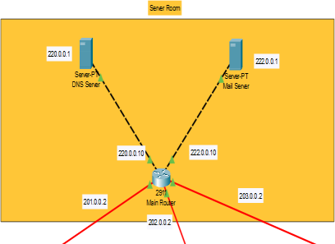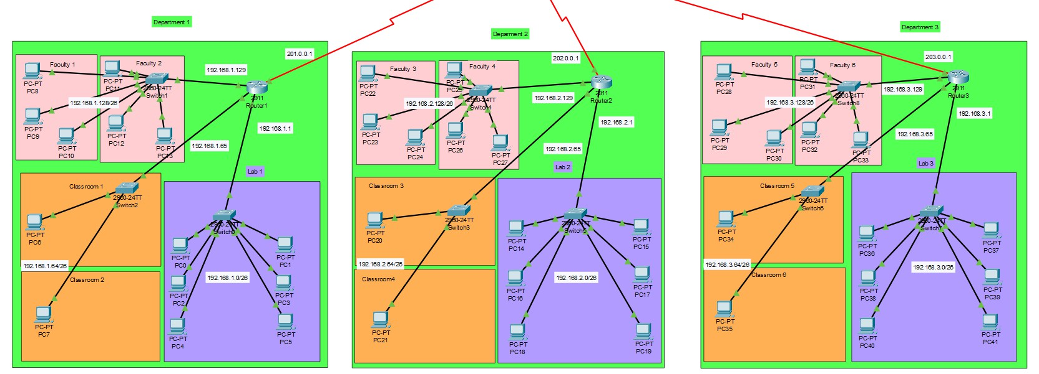

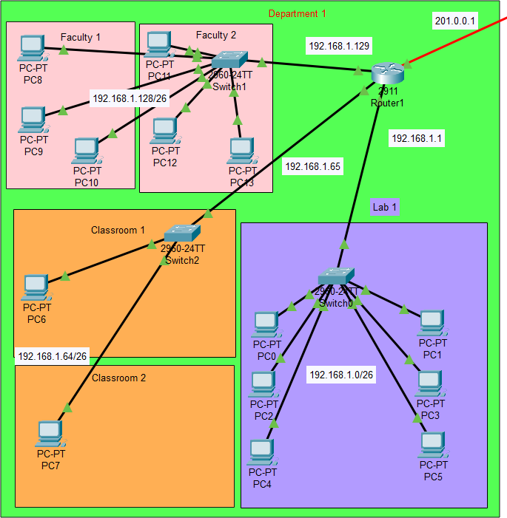

# 

# Server Room Setup

The **Server Room** serves as the central hub of the FCAI network, providing shared services to all three departments. Its design is a crucial part of the overall topology, ensuring that network-wide services such as DNS and email are efficiently managed and accessible from any department. The Server Room is strategically placed at the core of the network to act as the centralized point of communication and resource distribution.

#### ****Purpose of the Server Room****

The Server Room houses two critical servers:

* **DNS Server**: Responsible for resolving domain names to IP addresses, enabling user-friendly communication within the network.
* **Mail Server**: Handles email services, allowing users from different departments to send and receive emails within the institutional network.

These servers provide centralized services that are essential for a fully functional academic network environment. Centralization not only ensures better manageability but also reduces redundancy and simplifies maintenance.

#### ****Hardware Components Used****

* **2 Servers**: One for DNS, one for Mail services
* **1 Main Router**: Connects the Server Room to all three departmental routers via serial links
* **Serial and Ethernet Cables**: Used to interconnect routers and servers
* **Network Interface Cards (NICs)**: Installed on all servers to allow proper communication with the router

#### ****Connectivity and Integration****

The servers are directly connected to the **Main Router** using **Ethernet connections**, while each of the **three departmental routers (Router1, Router2, Router3)** is connected to the Main Router through **serial connections**. This allows for:

* Easy and direct access to server resources from any department
* Controlled routing of data packets between departments and servers
* Effective monitoring and management of server traffic from a central point

Each departmental router is configured to communicate with the Main Router so that any DNS request or email sent from a PC in the lab, classroom, or faculty office first passes through the departmental router, then the Main Router, and finally reaches the appropriate server in the Server Room.

#### ****Server Configuration Summary****

* **DNS Server**:
  + Contains hostname-to-IP mappings for all PCs (pc0 to pc41)
  + Provides name resolution services to every device in the network
* **Mail Server**:
  + Stores and manages institutional email accounts for all users
  + Communicates with client PCs configured with email addresses

The Server Room's central placement ensures that critical network functions are consolidated and protected, minimizing the risk of data loss or network outages. By using serial routing and structured IP addressing, the server setup allows each department to seamlessly access and utilize shared services without performance bottlenecks.

# IP Addressing & Subnetting

A structured and well-planned IP addressing scheme is essential for organizing network traffic, managing devices efficiently, and ensuring seamless communication across departments. In this project, a **class C private IP range** was used and carefully subnetted to accommodate different zones within each department—specifically, Labs, Faculty Offices, and Classrooms.

#### ****Why Subnetting Was Needed****

Since each department contains multiple devices spread across three main areas, subnetting allows:

* Logical separation of traffic for better performance and security
* Easier assignment of IP addresses using DHCP
* Simplified routing within and across departments
* Efficient use of the IP address space

Subnetting also ensures that broadcast domains are limited to their respective zones, avoiding unnecessary traffic throughout the network.

#### ****Subnetting Strategy****

Each department was assigned a unique base IP range:

* **Department 1**: 192.168.1.0/24
* **Department 2**: 192.168.2.0/24
* **Department 3**: 192.168.3.0/24

Each /24 block was further divided into **four subnets of /26** to support individual segments:

| **Subnet Range** | **Usage** | **Subnet Mask** | **Hosts Available** |
| --- | --- | --- | --- |
| 192.168.x.0/26 | Lab | 255.255.255.192 | 62 |
| 192.168.x.64/26 | Faculty Offices | 255.255.255.192 | 62 |
| 192.168.x.128/26 | Classrooms | 255.255.255.192 | 62 |
| 192.168.x.192/26 | **Reserved** | 255.255.255.192 | 62 |

Note: The last subnet (.192/26) in each department was reserved for **future expansion**.

For example, in **Department 1**:

* **Lab**: 192.168.1.0/26
* **Faculty Offices**: 192.168.1.64/26
* **Classrooms**: 192.168.1.128/26
* **Reserved**: 192.168.1.192/26

The same logic was applied to Departments 2 and 3 using their respective IP blocks.

#### ****DHCP and IP Assignment****

Each departmental router was configured to act as a **DHCP server**, assigning IPs dynamically to the PCs within its subnetworks. For each subnet:

* The **first IP address** was assigned to the router’s interface
* The **remaining addresses** were reserved for end-user devices
* Custom **DHCP pools** were created with default gateways and DNS server addresses

#### ****Benefits of This Addressing Scheme****

* **Scalability**: Each subnet supports up to 62 hosts, more than enough for current needs and future growth.
* **Manageability**: Logical segmentation makes it easier to monitor, diagnose, and control traffic.
* **Security**: Isolated subnets help reduce cross-network vulnerabilities.
* **Efficiency**: Optimized use of IP ranges avoids wastage of addresses.

This carefully planned IP addressing and subnetting structure forms the backbone of the network, enabling organized connectivity and reliable routing across all devices and departments.

# DHCP Configuration

To simplify IP address management and reduce manual configuration errors, the **Dynamic Host Configuration Protocol (DHCP)** was implemented within each department of the network. DHCP automates the assignment of IP addresses, subnet masks, default gateways, and DNS server addresses to all end-user devices (PCs), streamlining the overall network configuration process.

Each of the three departmental routers (Router1, Router2, and Router3) was configured to act as a **DHCP server** for its respective department. These routers are connected to three different switches that handle the traffic from the Lab, Faculty Offices, and Classrooms.

#### ****DHCP Design Strategy****

Each department’s /24 IP range was divided into three /26 subnets:

* **One subnet** for the Lab PCs
* **One subnet** for Faculty Office PCs
* **One subnet** for Classroom PCs

Within each subnet:

* The **first usable IP address** is assigned to the router interface
* The **remaining IPs** are dynamically distributed to the connected PCs through DHCP

Each DHCP pool is configured with:

* A **network address and subnet mask**
* A **default gateway** (router’s interface IP)
* A **DNS server address** (pointing to the centralized DNS Server)

#### ****Example DHCP Configuration****

Below is a sample configuration for setting up DHCP on **Router1** (Department 1):

Router> enable

Router# configure terminal

Router(config)# interface GigabitEthernet0/2

Router(config-if)# ip address 192.168.1.1 255.255.255.192

Router(config-if)# no shutdown

Router(config-if)# exit

Router(config)# ip dhcp pool LAB1

Router(dhcp-config)# network 192.168.1.0 255.255.255.192

Router(dhcp-config)# default-router 192.168.1.1

Router(dhcp-config)# dns-server 220.0.0.1

Router(dhcp-config)# exit

The same process was repeated to configure DHCP for the **Faculty Offices** and **Classrooms** in Department 1 using:

* 192.168.1.64/26 for Faculty Offices
* 192.168.1.128/26 for Classrooms

Routers for **Department 2 and 3** were configured in the same way, using their respective IP blocks (192.168.2.0/24 and 192.168.3.0/24).

#### ****Client Configuration****

All PCs across Labs, Offices, and Classrooms were set to obtain their IP address automatically via DHCP:

* IP configuration was set to **DHCP** mode from the PC’s desktop interface in Cisco Packet Tracer
* Upon boot-up, the PCs sent a **DHCP Discover** request and received IP addresses and gateway information from their department's router

#### ****Advantages of DHCP Implementation****

* **Automation**: Reduces manual effort in assigning and managing IPs
* **Consistency**: Ensures correct and conflict-free IP assignments
* **Flexibility**: Easily supports device additions and network changes
* **Centralized Management**: Each router handles its own address pool, simplifying troubleshooting

By deploying DHCP at the router level in each department, the network becomes highly **efficient**, **scalable**, and **easy to manage**, while allowing each zone to function independently under a unified network design.

# DNS and Mail Server Configuration

Centralized DNS and Mail Server services are vital components of any institutional network. In this project, both were configured within a dedicated Server Room to serve all three departments of the Faculty of Computing and AI. These servers provide essential services such as domain name resolution and institutional email communication, ensuring a smooth digital experience for students, faculty, and administrative users.

#### ****DNS Server Configuration****

The **Domain Name System (DNS) Server** was set up to translate human-readable domain names into machine-readable IP addresses.This simplifies communication and navigation across the network.

**Steps Taken:**

1. The DNS server was connected to the **Main Router** in the Server Room using an Ethernet cable.
2. All PCs in the network were given **hostnames** (e.g., pc0, pc1, ..., pc41) based on their department and role.
3. On the DNS server configuration page:
   * Each PC's hostname and IP address were added to the DNS records.
   * A default domain (e.g., fcai.edu) was assigned.
4. Routers in each department were configured to use the DNS server’s IP (220.0.0.1) in their **DHCP pools**, so PCs automatically received the correct DNS information.

This setup enabled all devices to resolve hostnames locally within the network, eliminating the need for IP-based communication and improving user experience.

#### ****Mail Server Configuration****

The **Mail Server** was configured to provide internal email communication across departments. It allows students, faculty, and staff to exchange messages within the campus network.

**Configuration Process:**

1. The Mail Server was also connected to the **Main Router** via Ethernet in the Server Room.
2. User accounts were created on the Mail Server using a consistent naming convention (e.g., pc0@fcai.edu, pc1@fcai.edu).
3. Each PC was configured with:
   * Email client settings
   * Assigned email ID and domain
   * Incoming and outgoing mail server settings pointing to the Mail Server’s IP
4. Email accounts were verified by sending test emails between departments (e.g., from a Lab PC in Department 1 to a Classroom PC in Department 3), confirming that the mail server was functioning correctly.

#### ****Benefits of Centralized Server Configuration****

* **Ease of Maintenance**: One location to manage both DNS and Mail services
* **Consistent Access**: All departments use a single DNS and Mail infrastructure
* **Efficient Communication**: Internal email and hostname resolution improve productivity
* **Network-Wide Integration**: All devices are linked through the central server room, enhancing uniformity

This server configuration mirrors real-world enterprise environments where centralized servers handle critical services for distributed clients, ensuring scalability, reliability, and professional-grade performance across the entire network.

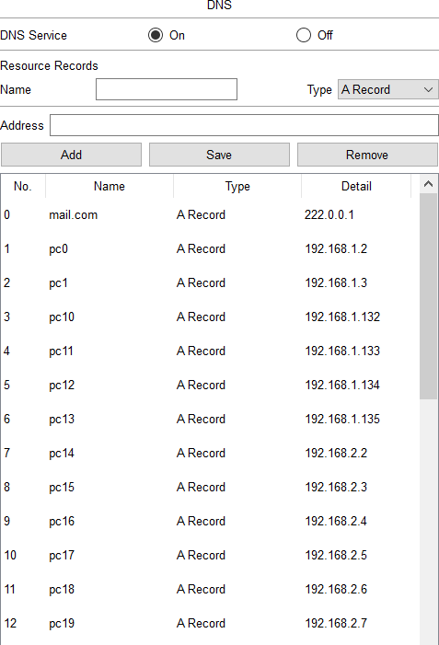 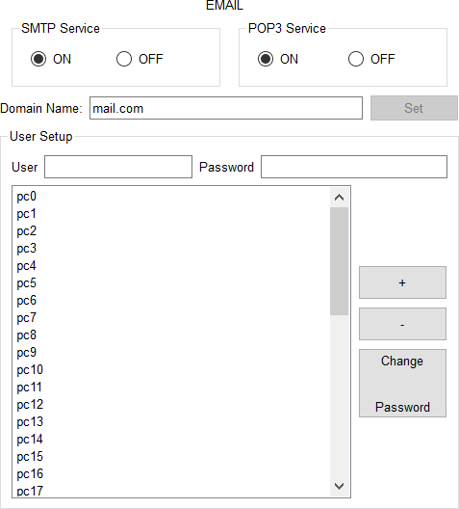

# Static and Dynamic Routing Configuration

Routing is the core mechanism that allows communication between different departments and the centralized Server Room within the FCAI network. In this project, both **static routing** and **dynamic routing (RIP)** were implemented to ensure reliable data transmission between all nodes across the network.

By combining these two routing techniques, the network benefits from optimized control over critical paths (via static routing) and automatic adaptability for inter-departmental communication (via dynamic routing).

#### ****Static Routing (Between Departments and Server Room)****

**Static routes** were configured on the **Main Router** and each departmental router to ensure direct communication between departments and the centralized Server Room, where the DNS and Mail Servers are located.

##### **Why Static Routing?**

* Provides **manual control** over routing paths
* Ideal for small, stable networks like department-to-server communication
* Ensures **reliable access** to the DNS and Mail servers

##### **Example: Static Routing on Main Router**

MainRouter(config)# ip route 192.168.1.0 255.255.255.0 Serial0/0/0

MainRouter(config)# ip route 192.168.2.0 255.255.255.0 Serial0/0/1

MainRouter(config)# ip route 192.168.3.0 255.255.255.0 Serial0/0/2

Each departmental router also had static routes pointing back to the Server Room subnet and the IPs of the DNS and Mail servers.

#### ****Dynamic Routing (Between Departments Using RIP)****

To simplify communication **between departments**, **Routing Information Protocol (RIP)** was configured. This allows routers to share routing information automatically, adapting to topology changes without manual updates.

##### **Why Use RIP?**

* Automates the process of route discovery
* Reduces administrative overhead
* Ideal for **homogeneous environments** with simple hierarchies

##### **RIP Configuration Example:**

On **Router 1**:

Router(config)# router rip

Router(config-router)# version 2

Router(config-router)# network 192.168.1.0

Router(config-router)# network 10.0.0.0

Similar RIP configurations were applied on **Router 2** and **Router 3**, using their respective IP networks. All routers were also included in the same RIP process so they could dynamically learn each other’s routes.

#### ****Routing Summary****

| **Routing Type** | **Used For** | **Routers Involved** |
| --- | --- | --- |
| Static Routing | Server Room ↔ Departments | Main Router & All Departments |
| Dynamic Routing | Department ↔ Department (via RIP) | Router1, Router2, Router3 |

#### ****Testing and Verification****

Once the routing was configured:

* Ping tests were conducted between PCs in different departments and to the servers
* Traceroute commands verified the path taken by data packets
* Successful communication confirmed that routing was correctly implemented and functioning

The combination of static and dynamic routing ensures that the FCAI network is both **robust and flexible**. Static routes provide dependable links to critical services, while dynamic routing simplifies internal communication between departments without requiring manual updates as the network evolves.

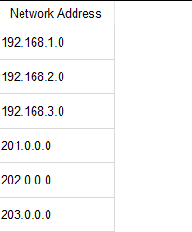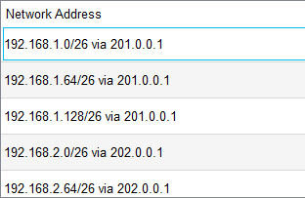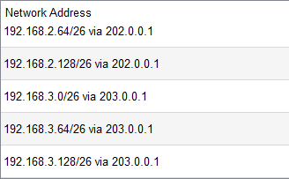

# Testing and Validation

Once the entire network setup and configuration were completed—including the design of topology, IP addressing with subnetting, DHCP configuration, DNS and Mail Server setup, and routing protocols—it was critical to thoroughly test the network to ensure its reliability, connectivity, and performance.

1. **Ping Testing:**

The first step in the validation process involved using the ping command to verify end-to-end connectivity across the network. Pings were conducted in a structured manner to cover the following scenarios:

1. **Intra-Departmental Pings:**
   * PCs within each department were tested to ensure proper connectivity within the same subnet.
   * All internal pings between the Lab PCs, Faculty Office PCs, and Classroom PCs within the same department returned successful replies, confirming that the DHCP servers were assigning valid IPs and switches were properly forwarding traffic.
2. **Inter-Departmental Pings:**
   * Cross-department communication was tested by pinging PCs in Department 2 from Department 1, and similarly for Department 3.
   * These pings were successful, indicating that the dynamic routing protocol (RIP) configured on the routers was correctly propagating routing information between departments.
3. **Server Access Pings:**
   * Each PC was tested for connectivity with the DNS and Mail Servers located in the central Server Room.
   * All devices were able to successfully ping the servers, demonstrating that the static routes configured on the Main Router were working correctly, and that the servers were properly integrated into the network.
4. **Ping Stability and Consistency:**
   * Multiple ping sequences were initiated to observe the stability of responses.
   * The latency remained low, and no packet loss was observed, highlighting the efficiency of the network design and the successful communication between hosts and servers.
5. **Email Testing:**

Following the ping tests, the Mail Server’s functionality was validated by configuring email clients on each PC with their assigned user credentials. The testing process included:

* Sending emails from PCs in Department 1 to PCs in Department 2 and 3.
* Verifying receipt of those emails on the recipient PCs.
* Testing internal mail flow within a single department.

All email messages were successfully sent and received without delays. This confirmed that:

* The DNS Server correctly resolved mail server addresses,
* The Mail Server was functioning efficiently,
* The network supported application-layer services such as email.

Screenshots of both successful pings and email transmissions are attached in the appendix to provide visual proof of the validation results.

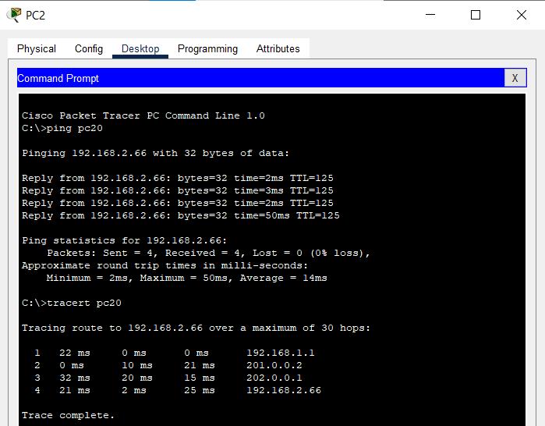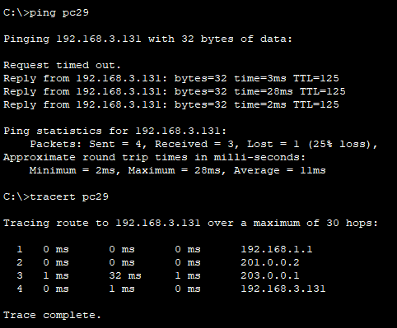

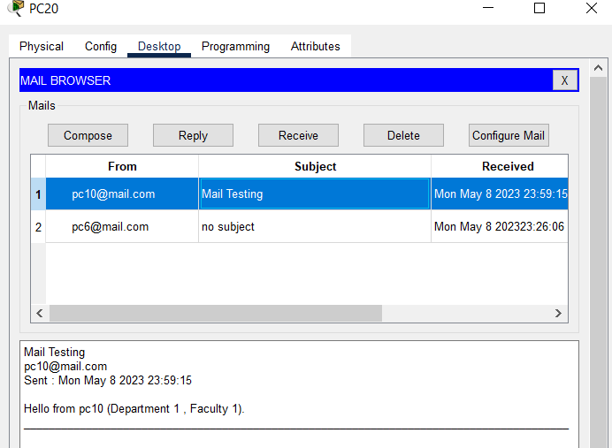

# Conclusion

The Project provided a comprehensive and practical experience in designing and implementing a scalable network infrastructure using Cisco Packet Tracer for the Faculty of Computing and AI (FCAI). The network was built to support three departments, each containing labs, faculty offices, and classrooms, with a focus on modular and uniform topology to simplify management and scalability.

The design process began with a clear departmental structure, followed by the physical layout and logical arrangement of devices such as PCs, switches, and routers. Each department was connected to a dedicated router, and all departmental routers were linked to a central Main Router located in a Server Room alongside the DNS and Mail Servers.

A systematic IP addressing scheme was employed using subnetting with the 192.168.x.0/26 structure, ensuring efficient allocation and future scalability. DHCP was configured on all departmental routers to automate IP assignment for different subnetworks—labs, faculty offices, and classrooms. The DNS Server was configured with hostnames and IP mappings for all PCs, while the Mail Server was prepared to handle internal communication by adding email accounts for each PC.

Routing was implemented using both **static** and **dynamic (RIP)** configurations. Static routes ensured direct communication between the departments and the Server Room, while RIP allowed seamless communication across departments.

To validate the network, extensive testing was conducted using ping commands to confirm device connectivity at all levels—intra-departmental, inter-departmental, and server access. Additionally, email functionality was verified through successful sending and receiving of messages across departments.

Overall, this project not only demonstrated the application of fundamental networking concepts but also reinforced the importance of systematic planning, address management, and layered testing in building a reliable network. It served as an excellent exercise in simulating real-world networking scenarios in an academic environment.

***The End***